**SWE320-Team Project Phase 2 Evaluation**

|  |  |  |  |
| --- | --- | --- | --- |
| **Project** **Title**: | | | **Team Code**: |
| **Items** | **Weight** | **Grade** | **Notes** |
| Design Viewpoints (sequence diagram, use case diagram, context diagram, class diagram, activity diagram) | 10 |  |  |
| Data Design | 4 |  |
| SRS | 3 |  |
| Requirements Matrix | 2 |  |
| Project Plan and task distribution | 1 |  |
| **SDD Document** | **20** |  |
| Achievement of project scope | 5 |  |
| Using MVC architecture | 5 |  |
| Data validation (JS+PHP) | 5 |  |
| The implementation conforms with the design | 5 |  |
| CRUD operations (as per the functional requirements) | 10 |  |
| Using OOP and design patterns (at least 2) | 10 |  |
| EAV Model or Dynamic Menu (self-reference) | 10 |  |
| Authentication (User Roles) | 10 |  |
| Testing (Test cases & Unit testing) | 10 |  |
| **Project Implementation** | **70** |  |
| **Project Total Grade** | **90** |  |

# **Team Individual Evaluation and Final Grade**

|  |  |  |  |  |  |
| --- | --- | --- | --- | --- | --- |
|  | **Group Lecture** | **ID** | **Name as in MIU ID** [Sorted in ascending order] | **Discussion (10)** | **Total (100)** |
| **1** | 1 | 2022/06148 | Akram Ayman Othman |  |  |
| **2** | 1 | 2022/02205 | Mazen Amir Effat Saeed |  |  |
| **3** | 1 | 2022/08461 | Mostafa Waleed Zaki |  |  |
| **4** | 1 | 2022/01063 | Omar Ehab Abdelaal Mohammed |  |  |
| **5** | 1 | 2022/01013 | Ramez Emad Ezzat Fahmy |  |  |

# GitHub repository

https://github.com/Omar400-cpu/Medira

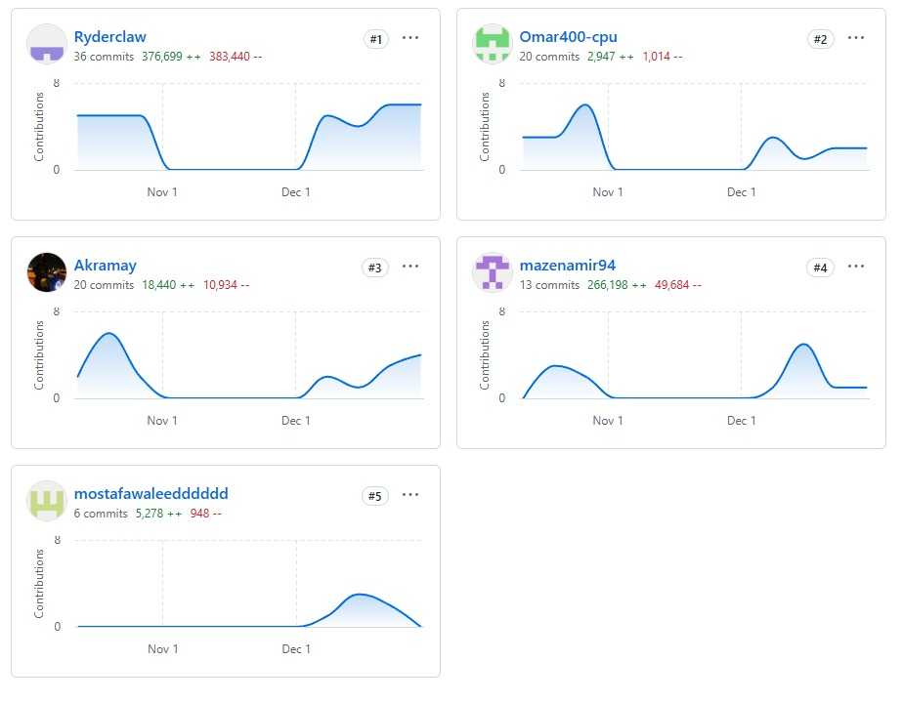

Github:Names

Ryderclaw:Ramez Emad

Akramy:Akram Ayman

# Tasks distribution:

|  |  |  |  |  |  |
| --- | --- | --- | --- | --- | --- |
| ID | Task name | Description | Start date | Duration in hours | Assigned to |
| 1 | ChatBot | Chatbot validation , functionality | 12/10/224 | 16hr | Omar Ehab |
| 2 | FrontEnd ContactUs | Design | 11/5/2024 | 2hr | Omar Ehab |
| 3 | FrontEnd Index | Design | 12/2/2024 | 4hr | Omar Ehab |
| 4 | Footer | Design | 12/15/2024 | 1hr | Omar Ehab,Akram Ayman |
| 5 | Discussion Form Front End | Design | 12/15/2024 | 5hr | Ramez Emad |
| 6 | Discussion Form BackEnd | Validation | 12/15/2024 | 6hr | Ramez Emad |
| 7 | Sign Up &Login In Backend | Validation | 12/5/2024 | 4hr | Ramez Emad |
| 8 | ContactUs BackEnd | Validation | 12/10/2024 | 3hr | Ramez Emad |
| 9 | Sign Up | Design | 12/8/2024 | 3hr | Akram Ayman |
| 10 | Login | Design | 12/8/2024 | 2hr | Akram Ayman |
| 11 | Animation Contact Us | Design | 12/23/2024 | Half An Hour | Akram Ayman |
| 12 | Signed Up | After user creates account there is an animation | 12/3/2024 | 2hr | Akram Ayman |
| 13 | Admin front end | Visualization of what admin can do | 12/10/2024 | 6 hours | Mazen Amir |
| 14 | Admin-backend | * Deleting users * Adding healthcare provider * Banning user * Validations of the forms * Showing messages from contact us * Discussion form oversight * Showing All Users to The Admin * Filtering Users by their Name Status , Role * Search function | 12/7/2024 | 18 hours | Mostafa waleed |
| 15 |  |  |  |  |  |
| 16 |  |  |  |  |  |
| 17 |  |  |  |  |  |
| 18 |  |  |  |  |  |
| 19 |  |  |  |  |  |
| 20 |  |  |  |  |  |
| 21 |  |  |  |  |  |